The Determination of Food Dye in Packaged Soft Drinks
Experiment Handout

Objective
- To determine the amount of food dye present in packaged soft drinks by LED colorimetry

Task
- To construct a home-made LED colorimeter
- To prepare an absorbance-concentration calibration curve for a series of standard solutions of a food dye using LED colorimetry
- To determine the amount of food dye present in a packaged soft drink sample by LED colorimetry

Background
Food dyes are often added into packaged food products to give the product a more appealing colour to attract customers. For example, Brilliant Blue FCF (E133) and Sunset Yellow FCF (E110) are two commonly used food dyes that can be found in a number of commercial products. Brilliant Blue FCF gives the product a blue colour whereas the Sunset Yellow FCF gives the product an orange shade. Each food dye comes with an E1xx number which indicates that they are artificial colorings permitted by the European Union for usage in food production.

Colorimetry is a common technique to determine the concentration of a compound in a solution if it has absorbance in the UV-visible range. Suppose I₀ is the intensity of a light beam before entering the solution and I_{s} is the intensity of the light beam after passing through the solution. For the same solution at different concentration and for the light beam of the same wavelength, it can be shown that the absorbance, A [which is defined as: A = log₁₀(I₀ / I_{s})] is proportional to the concentration of the coloured species in the solution, c, i.e., A = log₁₀(I₀ / I_{s}) ∝ c. Hence, the concentration of the coloured species can be determined by light intensity measurement.

In this experiment, you will determine the amount of Sunset Yellow FCF in a given packaged soft drink sample. You will be given a stock standard solution of Sunset Yellow FCF, from which you will prepare a series of standard solutions of different concentrations. The absorbances of these standard solutions are determined by light intensity measurements for plotting an absorbance-concentration calibration curve. You will then repeat the measurement for the drink sample so as to determine the amount of food dye present in the sample. All the light intensity measurements are done with a home-made LED colorimeter. The colorimeter consists of two LEDs: one as light source and one as light detector. When light is shining on the LED detector, a voltage is generated across its leads. The voltage is measured with a multimeter and it is assumed to be proportional to the light intensity.

Curriculum Link
Topic XV Analytical chemistry

Safety Precautions
- Wear safety glasses, lab coats and disposable plastic gloves.
- LED can produce high light intensity. Do not look directly at the LED when it is turned on.

Apparatus (per group)
- 250 cm³ beaker × 2
- 5 cm³ graduate pipette × 2
- 25 cm³ volumetric flask × 4
- 10 cm³ volumetric flask × 1
- Green LED as light source × 1
- Infra-red (IR) LED as light detector × 1
- Plastic cuvette × 1
- Digital multimeter × 1
- 3V button battery (CR2032) × 1
- Connecting wires × 2
- Disposable plastic dropper
- Blu-tack
- A plastic stand for holding a cuvette and two LEDs (produced by 3D printing)

Chemicals (per group)
- Stock solution of Sunset Yellow FCF (100 ppm)
(where 1 ppm = 1 part per million, which is equal to 1 mg dm^{–3} for solution)
- 5 cm³ of sample of a packaged soft drink

Procedure
Part A: Construction of LED colorimeter
- Insert the two LEDs (for light source and light detector) into the openings at the two opposite sides of the plastic stand. Secure the LEDs with Blu-tack.
- Insert a button battery between the leads of the green LED. If the LED is not switched on, flip the battery to reverse the poles.
- Connect the two leads of IR LED to multimeter and turn on the voltmeter and select a 2 or 3 V d.c. range. To avoid the short-circuiting of the leads, put a piece of paper between the leads. If negative value is shown on the multimeter, reverse the poles for the connection.
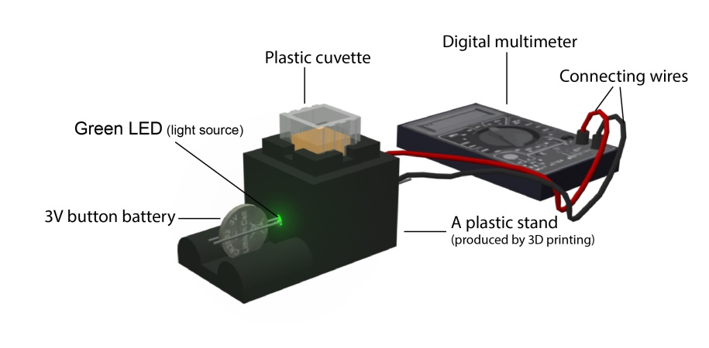
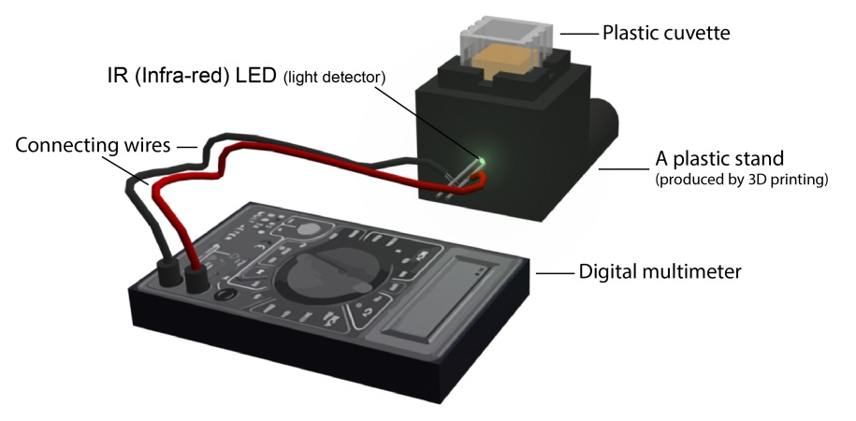
Part B: Preparation of Standard Solutions of Sunset Yellow FCF
- Prepare four Sunset Yellow FCF standard solutions by pipetting 5.0, 10.0, 15.0 and 20.0 cm³ of the given Sunset Yellow FCF stock solution into four 25 cm³ volumetric flasks respectively.
- Make up to the graduation using deionised water. There are five standard solutions and their concentrations are 20 ppm, 40 ppm, 60 ppm, 80 ppm and 100 ppm respectively.

Part C: Measurements for Standard Sunset Yellow FCF Solutions
- Rinse a cuvette and fill it at least half-full with deionised water. Wipe the outside of the cuvette with a tissue to make sure that the cuvette surfaces are clean and dry.
- Place the cuvette in the sample compartment of the colorimeter and record the multimeter reading for the LED detector. Note that the polished sides of the cuvette should face the LEDs.
- Repeat steps 1 and 2 for the five Sunset Yellow FCF standard solutions you obtained in Part B, starting from the one of 20 ppm. Rinse the cuvette with the solution to be measured.

Part D: Measurements for Packaged Soft Drink Sample
- Degas the packaged soft drink sample using an ultrasonic bath for 10 minutes, or leave the sample in air for 2 hours before use.
- Dilute the soft drink sample by pipetting 5.0 cm³ of the sample solution into 10 cm³ volumetric flask. Make up to the graduation using deionised water.
- Rinse a cuvette and fill it at least half-full with the diluted sample. Wipe the outside of the cuvette with a tissue to make sure that the cuvette surfaces are clean and dry.
- Place the cuvette in the sample compartment of the colorimeter and record the multimeter reading for the LED detector. Note that the polished sides of the cuvette should face the LEDs.

Results
- Assume that the voltage measured in Part C step (2) is directly proportional to the intensity of the light shining on the IR LED. Calculate the absorbance, A = log₁₀(I₀ / I_{s}) = log₁₀(V₀ / V_{s}) for each value of V_{s}.
 | Deionised water | Standard Solution |  |  |  |  | Sample solution
 |  | 20 ppm | 40 ppm | 60 ppm | 80 ppm | 100 ppm
Voltage measured
(V₀ or V_{s})
Absorbance (A)

- Plot a calibration curve (A vs c) below. Since A ∝ c, a straight line is expected.
- Determine the concentration of the food dye in the soft drink sample from the calibration curve.
From the calibration curve, the concentration of Sunset Yellow FCF in the given drink sample = _____________ ppm.
Questions for Discussion
 | 1. | The colours of many organic compounds are due to a long carbon chain of alternating single and double bonds in their molecules. Find out the molecular structure of Sunset Yellow FCF and verify that it also contains this feature.
 | 2. | Calculate the molarity of the Sunset Yellow FCF in the given drink sample.
 | 3. | What do you expect on the data if a yellow LED is used as the light source?
 | 4. | Suggest way(s) to improve the accuracy of the result obtained in this activity.
 | 5. | To analyse a small amount of manganese metal in a steel sample, the manganese metal is first converted to Mn²⁺ ions, followed by oxidation to MnO₄– ions. The overall conversion can be summarized in the two steps shown below:
Manganese metal + non-oxidizing acid Mn²⁺ ions (5A)
IO₄–(aq) + Mn²⁺(aq) + H₂O(l) IO₃–(aq) + MnO₄–(aq) + H⁺(aq) (5B, unbalanced)
 |  | The MnO₄– ions obtained in reaction 5B is then analysed with a colorimeter.
 |  | (a) | Write down the balanced chemical equation for the reaction 5A.
 |  | (b) | Balance the chemical equation for the reaction 5B.
 |  | (c) | Why is the Mn²⁺ ions obtained in the reaction 5A not analysed with colorimeter?
 |  | (d) | When using the colorimeter in this experiment to analyse the MnO₄–(aq), which of the follow LEDs should be used?
 | LED #1 | LED #2 | LED #3 | LED #4 | LED #5 | LED #6
Peak wavelength of light emitted / nm | 625 | 605 | 590 | 525 | 505 | 470

 | 6. | The figure below shows the working principle of a colorimeter common used in the last century.
Filter
Tungsten
lamp
Cuvette
Photo-
detector
 |  | (a) | What is the light source used in this colorimeter? State a difference between this light source and the LED in the colorimeter used in this experiment.
 |  | (b) | What is the purpose of the filter in this colorimeter? Why is it not needed in the colorimeter used in this experiment?

Reference
- “GL192 - A technical guide to setting up and using the CLEAPSS colorimeter”,
http://science.cleapss.org.uk/Resource-Info/GL192-A-technical-guide-to-setting-up-and-using-the-CLEAPSS-colorimeter.aspx

The sample provided has been degased.

