The Determination of Food Dye in Packaged Soft Drinks
Teacher Notes

Sample Results
- Assume that the voltage measured in Part C step (2) is directly proportional to the intensity of the light shining on the IR LED. Calculate the absorbance, A = log₁₀(I₀ / I_{s}) = log₁₀(V₀ / V_{s}) for each value of V_{s}.
 | Deionised water | Standard solution |  |  |  |  | Sample solution
 |  | 20 ppm | 40 ppm | 60 ppm | 80 ppm | 100 ppm
Voltage measured  (V₀ or V_{s}) | 96 | 41 | 23 | 12 | 10 | 7 | 23
Absorbance (A) |  | 2.341 | 4.174 | 8.000 | 9.600 | 13.714 | 4.174

- Plot a calibration curve (A vs c) below. Since A ∝ c, a straight line is expected.

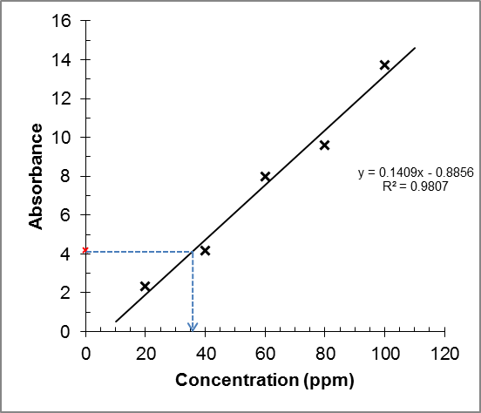

- Determine the concentration of the food dye in the soft drink sample from the calibration curve. From the calibration curve, the concentration of Sunset Yellow FCF in the given drink sample = 36 ÷ 5 cm³ × 10 cm³ = 72 ppm.
Answers for the questions:
(Teachers may choose the questions appropriate for their students to work out.)

 | 1.
 | 2. | The concentration of Sunset Yellow FCF in the given soft drink sample  = 72 ppm = 72 × 10^{–3} g dm^{–3}  Molar mass of Sunset Yellow FCF = 452.36 g  Molarity = 72 × 10^{–3} / 452.36 = 159 × 10^{–6} mol dm^{–3}
 | 3. | Sunset Yellow FCF solution is yellow in colour and hence it does not absorb yellow light. So, if yellow LED is used as the light source, there is little absorption of the light and all the values of V_{s} will be about the same as V₀, resulting in zero values for A.
 | 4. | - Do not move the battery and the LEDs in the colorimeter setup once their positions are secured.  - Great care should be taken when diluting the standard solutions. Auto-pipette may be used to increase accuracy.  - If the same cuvette is used for all solutions, it should be rinsed before filling it with the next solution of different concentration. The diluted solutions should be measured from low concentration to high concentration.  - LEDs are non-ohmic resistors. This means that the voltage produced by the detector LED may not be directly proportional to the light intensity shining on the LED. It may result in non-linearity of the calibration curve because the equation, A = log₁₀(I₀ / I_{s}) = log₁₀(V₀ / V_{s}), may no longer be valid. A polynomial function may be used to fit the data to obtain a better calibration curve. Curve fitting with non-linear function may be done with computer software such as MS Excel®.  - The use of a voltmeter with high impedance can make the voltage measurements more accurate.
 | 5. | (a) | Mn(s) + 2H⁺(aq) Mn²⁺(aq) + H₂(g)
 |  | (b) | 5IO₄–(aq) + 2Mn²⁺(aq) + 3H₂O(l) 5IO₃–(aq) + 2MnO₄–(aq) + 6H⁺(aq)
 |  | (c) | The colour of Mn²⁺ ions is very pale pink and light absorption will be very weak.
 |  | (d) | From the peak wavelengths of lights emitted given in the table, we can infer that the colour of the light emitted from the LEDs #1 to #6 is red, orange, yellow, green, cyan and blue, respectively. Since MnO₄–(aq) is purple in colour, it absorbs light of green colour, which is the complementary colour of purple. Hence, LED #4 should be used. Alternatively, from internet, the major absorption peaks of MnO₄–(aq) are located at 525 and 545 nm. Hence, LED #4 should be used. An example of the absorption spectrum of MnO₄–(aq) can be found at:  https://upload.wikimedia.org/wikipedia/commons/b/bf/Permanganate_spectrum.png
 | 6. | (a) | Tungsten lamp. It emits light of the whole visible spectrum whereas LEDs only emit light of a narrow band of visible spectrum.  [There are other differences but not related to the answer of the question of part (b) below.]
 |  | (b) | It is for filtering out the portions of the visible spectrum which are not absorbed by the sample solution. Since the LED emits light of a narrow band of visible spectrum, a filter is not needed to absorb the portions of light which are not absorbed by the sample solution.

