Reduction of Vanillin with Sodium Borohydride
Experiment Handout
Objective
- To reduce vanillin to vanillyl alcohol with sodium borohydride

Task
- To carry out the reduction of vanillin to vanillyl alcohol using sodium borohydride as the reducing agent

Background
Sodium borohydride is a mild reducing agent which is very useful for carrying out organic reduction reactions. It is useful for reducing aldehydes and ketones into primary alcohols and secondary alcohols, respectively. It is so mild that it reacts very slowly with alcohols and aqueous alkaline solutions. Therefore, the reduction with sodium borohydride can be conveniently carried out in aqueous alkaline solutions or using alcohols as the solvents. In contrast, lithium aluminium hydride, which is a much stronger reducing agent, can only be used in anhydrous diethyl ether as the solvent.

Another characteristic of the mild reducing power of sodium borohydride is that it only reduces aldehydes and ketones, but not carboxylic acids and esters, whereas the much stronger reducing power of lithium aluminium hydride makes it able to reduce aldehydes, ketones, carboxylic acids and esters.

In this experiment, vanillin (4-hydroxy-3-methoxybenzaldehyde) is reduced to vanillyl alcohol (4-hydroxy-3-methoxybenzyl alcohol) by sodium borohydride (NaBH₄). Vanillin is an aromatic compound found in a spice, vanilla. Sodium borohydride reduces the aldehyde group in vanillin to primary alcohol. To ensure the reaction to go to completion, an excess amount of sodium borohydride will be used in the reaction.

Curriculum Link
Topic V Fossil fuels and carbon compounds
Topic XI Chemistry of carbon compounds
Topic XV Analytical chemistry

Safety Precautions
- Wear safety glasses, lab coats and disposable plastic gloves.
- Sodium borohydride is corrosive and toxic. It is hazardous in case of skin contact, eye contact, ingestion and inhalation. It is also flammable. Handle it with great care.

Apparatus (per group)
- 25 cm³ conical flask × 1
- Disposable plastic dropper × 4
- Magnetic stir bar × 1
- Electric stir plate × 1
- Ice-water bath × 1
- Glass rod × 1
- Buchner funnel × 1
- Suction flask × 1
- Rubber cone × 1
- Filter paper
- Small test tube × 1
- TLC chamber × 2

Chemicals (per group):
- Vanillin 1 g
- 95 % ethanol 2 cm³
- Sodium borohydride 0.25 g
- 1 M NaOH 2 cm³
- 3 M HCl 6 cm³
- Propanone 1 cm³
- pH paper
- TLC plates
- Capillary tubes for TLC
- Iodine crystals
- Solvent for TLC (hexane / ethyl ethanoate 3:2) 5 cm³
- Vanillin solution (for TLC)
- Vanillyl alcohol solution (for TLC)

Procedure
Part A: Reduction of Vanillin with Sodium Borohydride
- Weigh accurately 1 g of vanillin solid in a 25 cm³ conical flask. Add 2 cm³ of 95 % ethanol into the flask.
- Add a magnetic stir bar to the flask and stir the mixture with an electric stir plate at room temperature.
- When the vanillin solid dissolves completely, cool the mixture in an ice-water bath.
- In a separate 25 cm³ conical flask, place 0.25 g of NaBH₄ and dissolve it with 2 cm³ of 1 M NaOH.
- Slowly add the NaBH₄ solution dropwise to the vanillin solution with a dropper. Add the NaBH₄ solution over a period of 3 minutes with continuous stirring and cooling since the reaction is exothermic.
- Remove the flask from the ice-water bath and allow the reaction mixture to be stirred at room temperature for 10 minutes.
- Cool the reaction mixture again with an ice-water bath. With stirring, add 3 M HCl(aq) dropwise to the reaction mixture until no more gas (which is H₂) evolves from the mixture.
- Check the pH of the reaction mixture by dipping a glass rod into it and then touch a piece of pH paper with the tip of the glass rod. Add more HCl(aq) if necessary to make sure that the reaction mixture is acidic.
- Cool the mixture with continuous stirring to allow the product to precipitate from the reaction mixture.

Part B: Isolation of the Reaction Product by Suction Filtration
- Assemble the apparatus for suction filtration by putting a rubber cone on the mouth of the suction flask and then putting a Buchner funnel on top of the rubber cone.
- Put a piece of filter paper of appropriate size into the Buchner funnel.
- Since the whole set of apparatus is easy to tilt, secure the suction flask with an iron stand and a clamp.
- Wet the filter paper with a small amount of cold water.
- Connect the suction flask to a water aspirator or a vacuum pump.
- Transfer the product mixture to the Buchner funnel to collect the solid product. You may use a small amount of ice-cold water to aid the transfer.
- Wash the product twice with small amount of ice-cold water. Leave the product on the Buchner funnel to dry.
- When the product is dried, collect the product and weigh it. Calculate the yield of the product obtained.
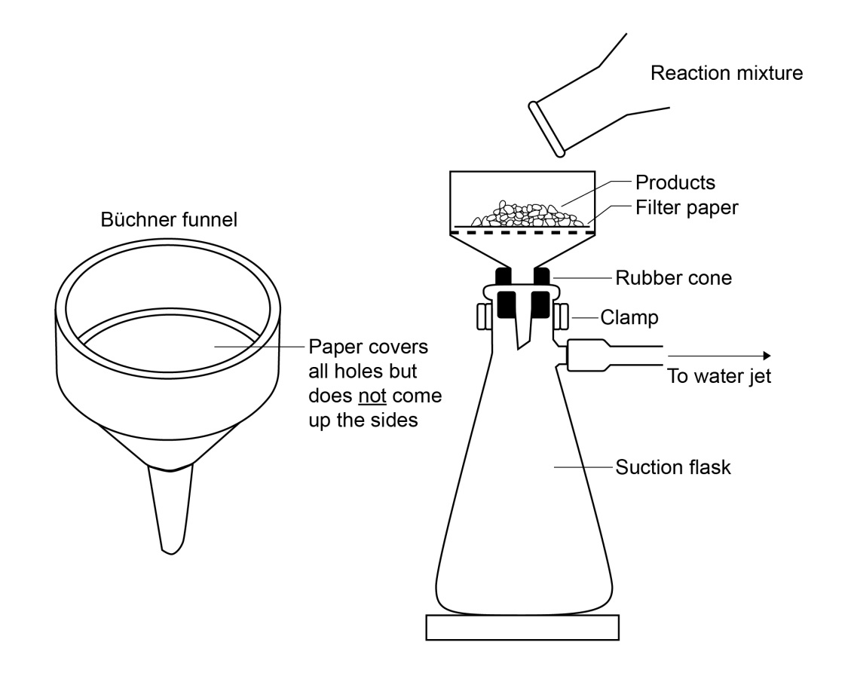
Part C: Analysis of the Product by Thin Layer Chromatography (TLC)
- Prepare the TLC sample by dissolving a small amount of the product in 1 cm³ of propanone in a small test tube.
- Spot the sample solution on a TLC plate by using a capillary tube.
- Spot the provided authentic solutions of vanillin and vanillyl alcohol on the same TLC plate for comparison.
- Prepare the TLC chamber by adding an appropriate amount of TLC solvent (hexane / ethyl ethanoate 3:2) into the chamber to about 3-4 mm deep.
- Place the TLC plate vertically into the chamber carefully. Make sure that the sample spots on the TLC plate are above the solvent level. Do not let the spots immersed in the solvent. Close the lid and allow the TLC plate to develop. Wait till the development is finished. Mark the solvent front with a pencil.
- Take the TLC plate out of the chamber and let the solvent on the plate evaporate completely.
- Prepare an iodine chamber by placing a few crystals of iodine into a clean TLC chamber.
- Put the developed TLC plate into the iodine chamber and close the lid. Wait till visible spots are formed on the plate.

Disposal and Clean-up
- After the experiment, dispose of the reaction mixture as instructed by the teacher. It is acceptable to rinse the mixture down into drain with plenty of water.
- Dispose of the filtrate in the suction flaks into drain and flush with plenty of water.
- Dispose of the filter paper, TLC plate and capillary tubes as normal refuse.

Results
Observations
Addition of NaBH₄ solution into vanillin solution cooled in an ice-water bath.
Warming the reaction mixture to room temperature.
Addition of 3 M HCl(aq) into the reaction mixture.
Further cooling of the mixture in the ice-water bath.
The filtrate obtained in the suction filtration.
The product collected in the suction filtration.
The spots on TLC plate before putting into the iodine chamber.
The spots on TLC plate after putting into the iodine chamber.

Draw the TLC result here:

Experimental Data
Molar mass of vanillin / g mol^{–1} :
Mass of vanillin used / g :
Number of mole of vanillin used / mol :
Molar mass of vanillyl alcohol / g mol^{–1} :
Mass of vanillyl alcohol obtained / g :
Number of mole of vanillyl alcohol obtained / mol :
Percentage yield :

Questions for Discussion
- Draw the structural formulae for vanillin and vanillyl alcohol. Point out their structural difference. Search online for their structural formulae if necessary.

- Predict the main difference in the infra-red (IR) spectra of vanillin and vanillyl alcohol.

- The chemical formula of borohydride ion is BH₄⁻. Draw the Lewis formula for it. Given an example of a common molecule and a common cation which have the same molecular shape with BH₄⁻ ion.

- How do you test whether the gas produced in Part A step (7) is hydrogen gas?

- Since NaBH₄ is used in excess amount in this experiment, it is left in the reaction mixture after the reaction is complete. Addition of HCl(aq) in Part A step (7) can consume all the remaining NaBH₄. Explain why the use of pH paper in step (8) helps you check whether all NaBH₄ left has reacted with HCl(aq).

- In some industrial processes of reduction of organic compounds, hydrogen gas is used for the reduction with an appropriate catalyst. Why is this reduction method seldom used in a school laboratory?

- Describe the purpose of iodine chamber in this experiment.

- The following conversion is part of a synthesis of a group of researchers. They successfully carried out this reduction with NaBH₄.
Suggest a reason why LiAlH₄ cannot be used for this conversion.

