Reduction of Vanillin with Sodium Borohydride
Teacher Notes

Sample results
 | Observations
Addition of NaBH₄ solution into vanillin solution cooled in an ice-water bath. | White fume formed. Heat is evolved.
Warming the reaction mixture to room temperature. | No observable change.
Addition of 3 M HCl(aq) into the reaction mixture. | Heat is evolved.
Further cooling of the mixture in the ice-water bath. | White solid formed.
The filtrate obtained in the suction filtration. | Colourless solution.
The product collected in the suction filtration. | White shiny powder obtained.
The spots on TLC plate before putting into the iodine chamber. | No observable change.
The spots on TLC plate after putting into the iodine chamber. | Brown spots at different heights observed.

Draw the TLC result here:
RM : Reaction mixture
P : Product, vanillyl alcohol
R : Reactant, vanillin

Experimental Data
Molar mass of vanillin / g mol^{–1} : | 152.15
Mass of vanillin used / g : | 1.00
Number of mole of vanillin used / mol : | ${\text{1.00} \text{g}}/{\text{152.15 g }{\text{mol}}^{\text{-1}}}$  = 0.006572 mol
Molar mass of vanillyl alcohol / g mol^{–1} : | 154.17
Mass of vanillyl alcohol obtained / g : | 0.46 (For reference only)
Number of mole of vanillyl alcohol obtained / mol : | ${\text{0.46}\text{ g}}/{\text{15}\text{4}\text{.1}\text{7}\text{ g }{\text{mol}}^{\text{-1}}}$  = 0.002984 mol
Percentage yield : | $\text{(}{\text{0.002984 mol }}/{\text{0.006572 mol}}\text{) × 100\%}$  = 45.40 %
Answers for the questions:
(Teachers may choose the questions appropriate for their students to work out.)

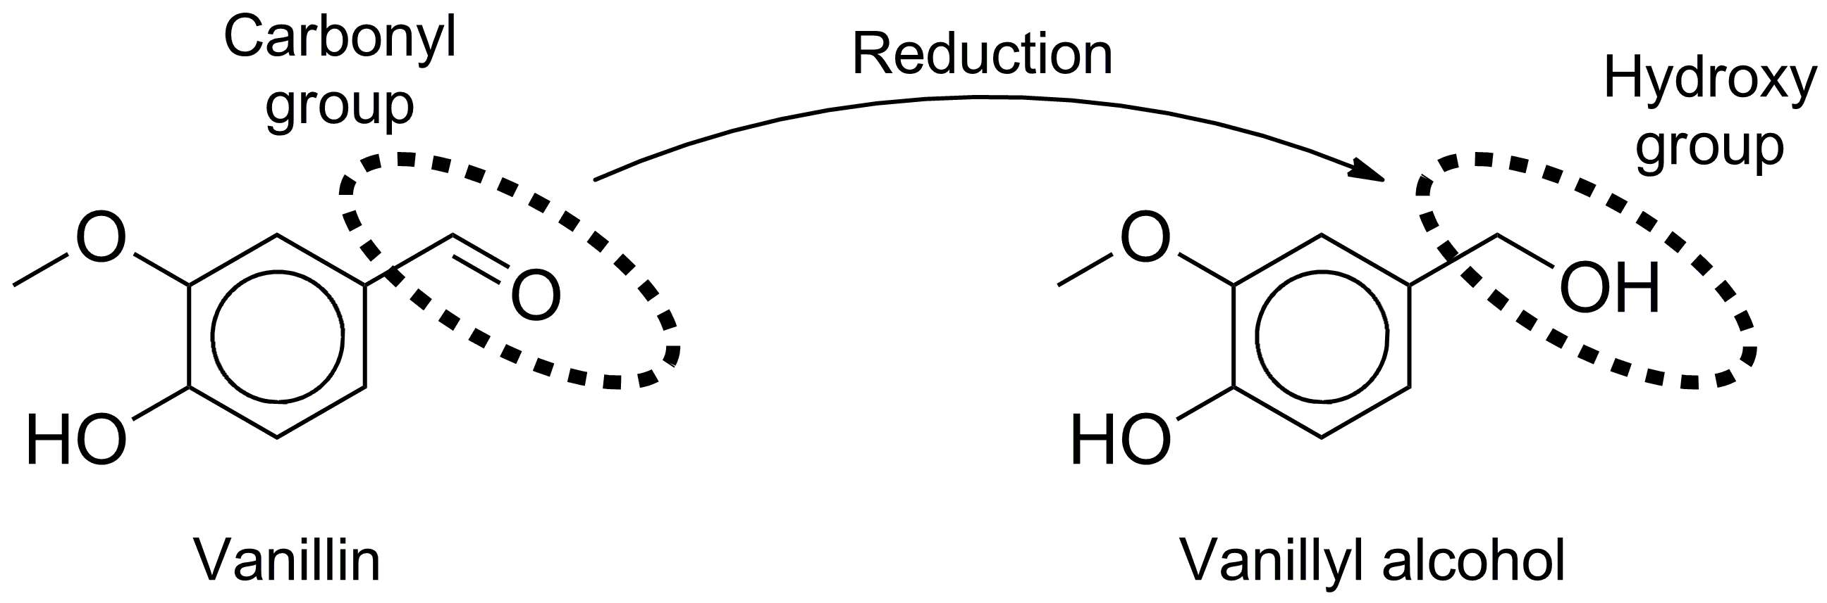
Structural difference: there is a carbonyl group in vanillin, but at the same carbon, there is a primary hydroxyl group.

- In the IR spectrum of vanillin, there should be a peak in the range from 1680 to 1800 cm^{–1} for the carbonyl group, but such a peak is not expected in the IR spectrum of vanillyl alcohol.

Common molecules which have the same molecular shape: CH₄, CCl₄, etc.
Common cation which has the same molecular shape: NH₄⁺

- Collect the gas in an inverted test tube and bring a burning splint to the mouth of the test tube to check if a pop sound is produced.

- BH₄– reacts with H⁺ readily. If the mixture is acidic, there is excess H⁺ in the mixture, which implies that all NaBH₄ left has reacted with HCl(aq).

- High-pressure hazard may be involved. Contact of hydrogen gas and open fire or spark may results in explosion. Other possible reasons: the catalyst is expensive, the reaction time may be long, etc.
- Vanillin and vanillyl alcohol are colourless and the spots for these two compounds cannot be detected by naked eyes. In iodine chamber, the vapourised iodine reacts with these two compounds to produce coloured spots for visual observation.

- LiAlH₄ may also reduce the ester group in the compound.

