1A
Preparation of Nitrogen Monoxide and Study of Its Chemical Properties (microscale experiment)
Students’ Handout
Objectives
- To prepare nitrogen monoxide from sodium nitrite and acidified iron(II) sulphate solution.
- To study the oxidising and reducing properties of nitrogen monoxide with (1) acidified potassium permanganate solution, (2) bromine water, (3) acidified iron(II) sulphate solution, and (4) air (oxygen).
Background
Nitrogen monoxide (NO) is a colourless gas. It can be prepared by the reaction of sodium nitrite with acidified iron(II) sulphate solution:

Nitrogen monoxide is very reactive and is readily oxidised in air to produce nitrogen dioxide:
Nitrogen monoxide has a very limited solubility in water. The oxidation state of nitrogen in nitrogen monoxide is +2. Since typical oxidation state of nitrogen ranges from -3 to +5, nitrogen monoxide has both oxidising and reducing properties with suitable reagents.

In this experiment, you will prepare nitrogen monoxide (NO) gas in a syringe using the reaction between solid sodium nitrite and acidified iron(II) sulphate solution. The gas produced is then cleaned in the syringe by simple steps. Finally, you will study the redox properties of nitrogen monoxide by allowing it to react with a number of reagents separately: (1) Acidified potassium permanganate solution, (2) bromine water, (3) acidified iron(II) sulphate solution, and (4) air (oxygen).

Curriculum Link
Topic VII Redox Reactions, Chemical Cells and Electrolysis

Safety Precautions
- Wear safety glasses, laboratory coats and disposable plastic gloves.
- The experiment should be carried out in a fume cupboard. In case the amount of nitrogen monoxide generated is more than the syringe can contain, let the excess gas escape from the syringe inside the fume cupboard.
- When examining the properties of nitrogen monoxide, use the minimum amount of it because excess nitrogen monoxide gas reacts with oxygen in air to give the brown nitrogen dioxide gas, which is poisonous.
- After completing the experiment, discharge all the gases in the fume cupboard.

Apparatus (per group)
- 250 cm³ Beakers × 3
- 100 cm³ Beaker × 1
- Test tubes × 3
- 100 cm³ Glass syringe × 1
- Syringe cap × 1
- Plastic vial cap × 1
- Spatula × 1
- White paper / White tile × 1
- Electronic balance × 1 (shared among groups)
- Test tube rack × 1

Chemicals (per group):
- NaNO₂(s) 0.25 g
- FeSO₄/H⁺(aq) 30 cm³
- 1 M NaOH(aq) 100 cm³
- KMnO₄/H⁺(aq) 10 cm³
- Br₂(aq) 10 cm³
- Deionised water 300 cm³
Procedure
Part A: Preparation of Nitrogen Monoxide
- Add 250 cm³ of deionised water into a 250 cm³ beaker.
- Pour about 100 cm³ of 1 M NaOH solution into another 250 cm³ beaker.
- Carry out the following for a 100 cm³ glass syringe:
- Insert the plunger into the syringe, and push and pull the plunger several times. Check whether the plunger moves smoothly in the syringe. Lubricate the plunger if necessary.
- Cap the syringe with the syringe cap and check whether the plunger moves smoothly in the syringe. If it does, there may be a leakage and then you should ask your teacher for help.
- Carry out the following steps so as to put NaNO₂ solid into the syringe in a neat manner:
- Weigh about 0.25 g of NaNO₂(s) with an electronic balance and transfer it into a vial cap. Make sure that the NaNO₂ solid is evenly placed in the cap.
- With the syringe tip pointing down without plunger, cap the tip (or plug the cap with finger), fill the upright-syringe with water. Put the vial cap prepared in (a) on the water surface. Uncap the syringe (or remove your finger) to allow water to drain out from the syringe. After water drains out completely, the vial cap should sit at the bottom inside the syringe. From now on, always keep the syringe in an up-right position with tip pointing down.
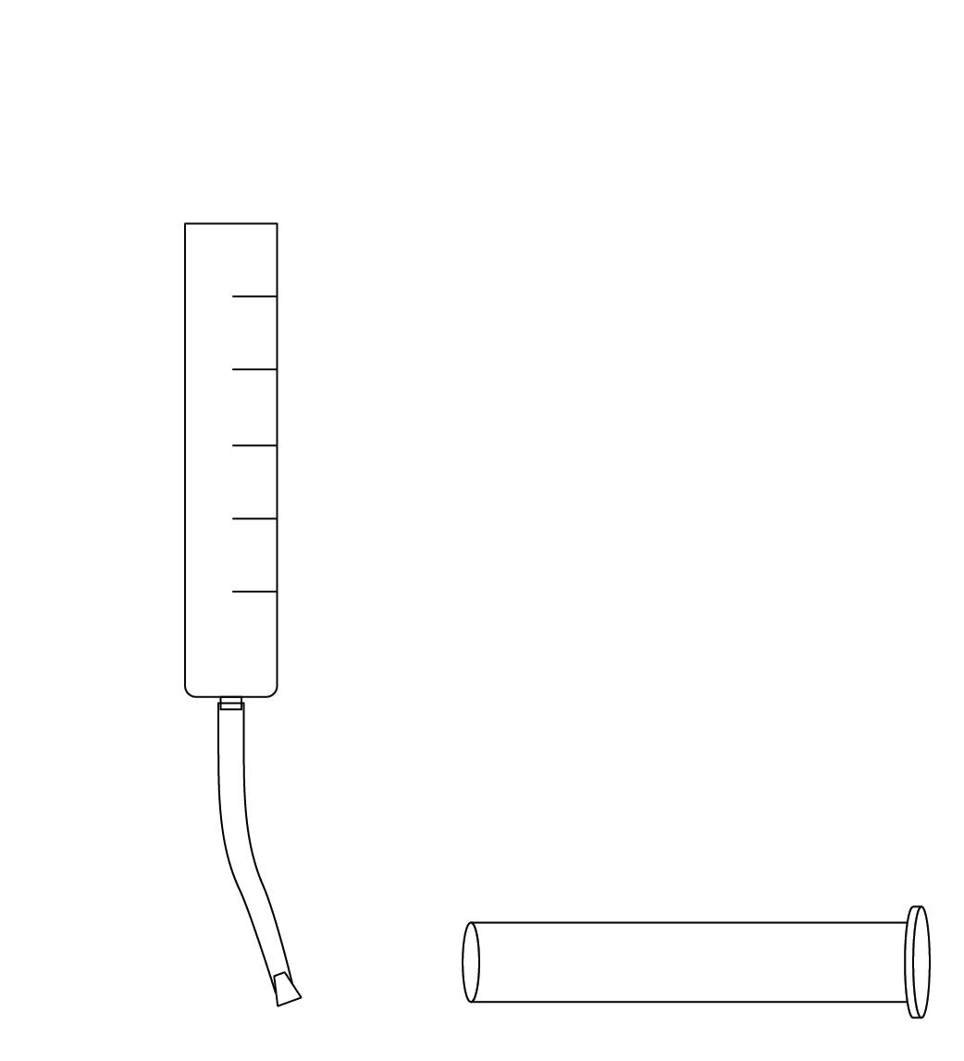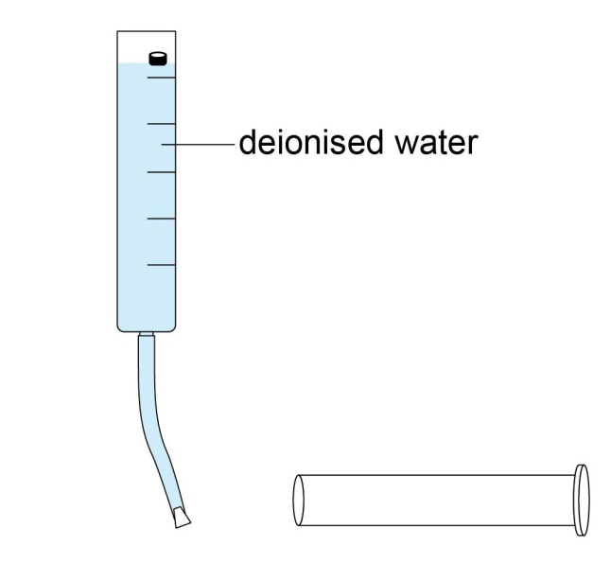

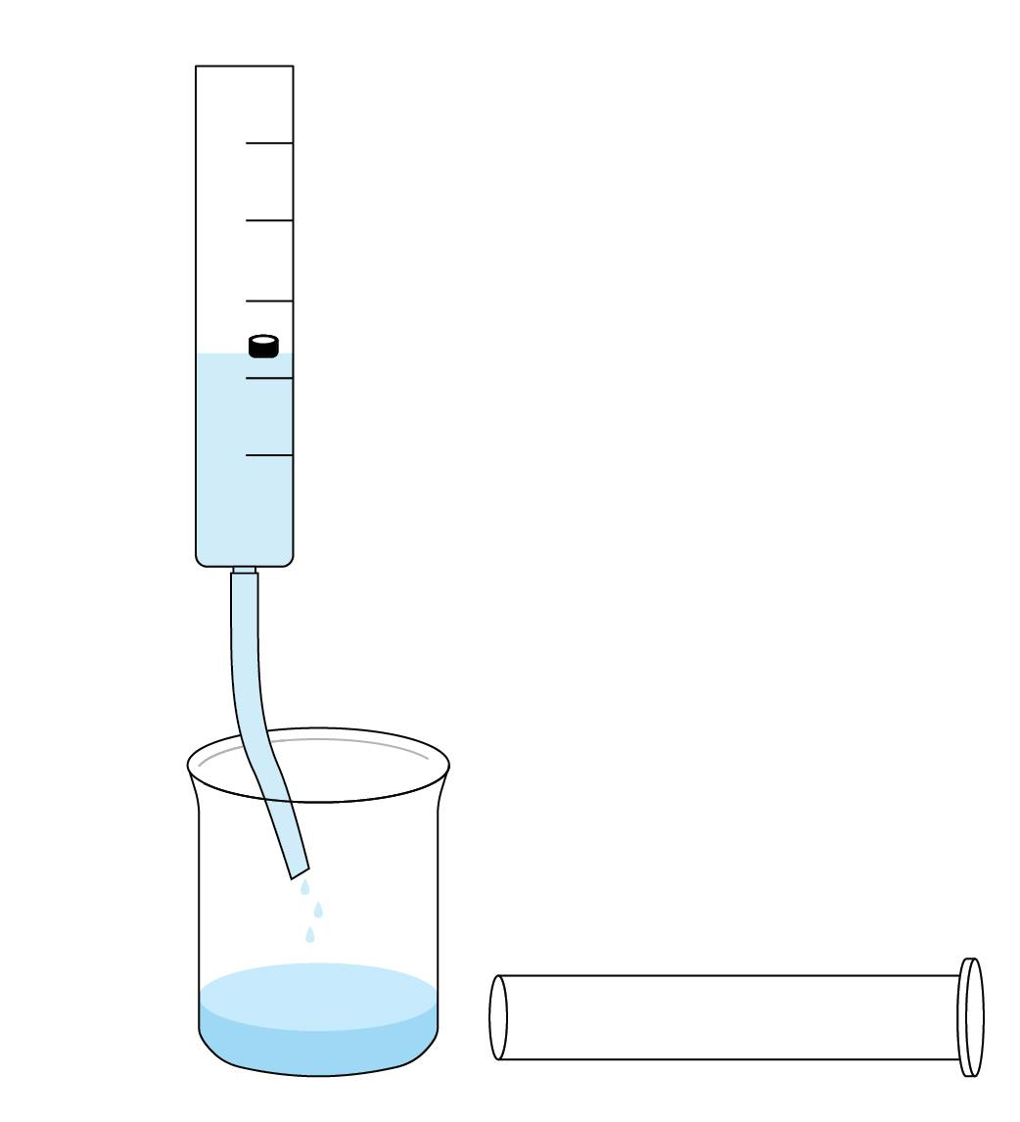

- Insert the plunger into the syringe with the tip of the plunger touching the vial cap, and draw about 4 cm³ of acidified FeSO₄(aq) into the syringe.
- Cap the syringe immediately.
- Shake the syringe gently to mix the NaNO₂(s) and the acidified FeSO₄(aq). Gaseous nitrogen monoxide is produced quickly from the reaction. It may be necessary to help the plunger to move out by pulling the plunger out slightly. The volume of NO(g) produced is expected to be about 60 cm³. Note: To prevent the reaction from going too fast, you should stop shaking when the reaction goes. Only when the reaction stops or goes slowly should you shake the syringe again. In case the amount of the nitrogen monoxide gas generated is more than the syringe can contain, let the plunger move out of the syringe (but with your hand holding the plunger to avoid falling) and allow excess gas to escape from the syringe.
- When the production of NO(g) is finished, hold the plunger and remove the syringe cap carefully. Discharge the solution inside the syringe into the 1M NaOH solution. Cap the syringe with the syringe cap immediately after discharging the solution.
- To wash away the contaminants from the collected NO(g) with deionised water, remove the syringe cap and draw about 10 cm³ of deionised water into the syringe. Cap the syringe again and shake or swirl the syringe to wash the gas inside the syringe. Remove the cap and discharge the water from the syringe.
- Repeat step 9 for 2 to 3 times. Cap the syringe with the syringe cap, and the preparation of NO(g) is done.

Part B: Study of the Oxidising and Reducing Properties of Nitrogen Monoxide
- Place a piece of white paper (or a white tile) behind three test tubes to aid observation.
- Add 5 cm³ of acidified KMnO₄(aq), Br₂(aq), and acidified FeSO₄(aq) to these test tubes respectively.
- Inject a small amount of nitrogen monoxide from the syringe into each of the solutions and record the changes observed.
- With NO(g) left in the syringe, suck in small amount of air into the syringe by pulling the plunger slowly. Record the observation.

Disposal and Clean-up
- Remaining NO₂(g) in the syringe can be treated by drawing some water into the syringe, followed by discharging the solution from the syringe into 1 M NaOH solution.
- After the experiment, dispose of all solutions into a chemical waste bottle.
- Rinse the glassware and apparatus with water.

Results
Observations
Appearance of the solid NaNO₂.
Appearance of the acidified FeSO₄ solution.
Mixing NaNO₂(s) with acidified FeSO₄ solution.
Washing NO(g) with deionised water.
Appearance of NO(g).
Before and after adding NO(g) to
(1) acidified KMnO₄(aq).
(2) Br₂(aq).
(3) acidified FeSO₄(aq).
After mixing NO(g) with air (O₂(g)).

Questions
- In the reaction between NaNO₂(s) and FeSO₄/H⁺(aq),
      - which one is the limiting reagent? Given: The FeSO₄ solution is prepared by dissolving 33.8 g of FeSO₄·7H₂O in 90 cm³ of water, followed by addition of 10 cm³ of concentrated sulphuric acid.

      - calculate the theoretical volume of NO(g) produced. Assume the gas is produced under room temperature and pressure.

      - which one is the oxidising agent and which one is the reducing agent? Explain your answer in terms of the changes in oxidation numbers.

      - write down the half-equations for the oxidation and reduction occurred in the reaction between NaNO₂(s) and FeSO₄/H⁺(aq).

      - what is the observable change occurred in the reaction between NO(g) and FeSO₄/H⁺(aq)? Write a balanced equation for the reaction.

- What is the observable change occurred in the reaction between NO(g) and acidified KMnO₄(aq)? Write a balanced equation for the reaction.

- What is the observable change occurred in the reaction between NO(g) and Br₂(aq)? Write a balanced equation for the reaction.

- What is the observable change occurred in the reaction between NO(g) and O₂(g)? Write a balanced equation for the reaction.

