Report on estates in Hong Kong for older people
- Proportion of older people by district
From the 2016 Census data, the proportion of older people in 2016 ranged 14.6% to 17.2% across the 18 districts.
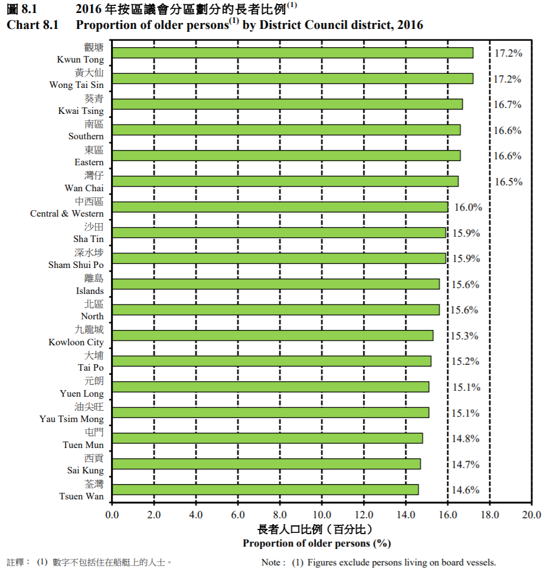

In terms of Tertiary Planning Unit (TPU), the proportion of older people in 2016 ranged from 8.5% to 26.4%. The TPU with the highest proportion of older people is Wong Chuk Hang (TPU 175-176).
TPU | % of people aged 65+
175 - 176 | 26.4
237 | 23.7
154 | 23.5
292 | 23.0
116 | 22.7
265 | 22.5
920 | 22.5
610, 621, 623, 626 and 632 | 22.3
620, 622, 641 - 642 and 651 - 653 | 22.2
325 | 21.9
234 | 21.5
287 | 21.5
755 | 21.0
542 - 546 | 20.9
835 | 20.8
148 - 149 | 20.8
294 - 295 | 20.7
283 | 20.7
262 | 20.7
236 | 20.5
758 | 20.4
911 - 913, 931 - 934 and 941 - 944 | 20.4
541 | 19.8
166 | 19.8
511, 513 - 514 and 516 - 517 | 19.6
821 and 826 - 828 | 19.6
759 | 19.4
146 - 147 | 19.4
132 | 19.3
328 | 18.9
297 | 18.8
282 | 18.8
961 - 963 and 976 | 18.7
153 | 18.6
246 | 18.6
172 | 18.6
263 | 18.4
113 - 114 | 18.3
243 | 18.3
173 | 18.3
227 | 18.1
231 - 233 | 18.0
161 | 18.0
261 | 17.9
547 - 548 | 17.9
151 | 17.9
228 | 17.7
723 | 17.7
164 - 165 | 17.7
121 - 124 and 133 - 135 | 17.6
711 - 712, 721 and 728 | 17.5
212 | 17.4
726 | 17.3
241 | 17.3
260 | 17.3
112 and 115 | 17.2
532 - 533 | 17.2
327 | 16.9
624 and 629 | 16.9
424 | 16.9
326 | 16.8
264 | 16.7
837 | 16.6
155 | 16.5
310 and 321 - 322 | 16.5
836 | 16.5
174 | 16.5
222 | 16.4
157 | 16.3
527 | 16.3
280 | 16.3
229 | 16.3
221 | 16.3
281 | 16.3
242 | 16.2
268 | 16.1
Land | 15.9
731, 733 and 754 | 15.8
524 | 15.7
111 | 15.7
211 | 15.7
350 | 15.7
351 | 15.6
423 and 428 | 15.5
225 | 15.4
288 - 289 | 15.3
512 and 515 | 15.1
163 | 15.0
167 | 15.0
293 and 296 | 15.0
421 - 422 | 15.0
531 | 15.0
284 | 14.9
131 | 14.9
141 | 14.9
272 | 14.7
235 | 14.6
266 | 14.6
291 | 14.6
521, 525 - 526 and 528 | 14.5
140 and 143 | 14.3
510 | 14.2
625 | 14.2
811 - 815, 822 and 825 | 14.1
323 | 14.1
838 | 14.0
156 and 158 | 13.9
820, 823 - 824 and 829 | 13.8
971 - 974 | 13.8
253 | 13.8
522 | 13.8
756 and 761 - 762 | 13.6
220 and 226 | 13.6
628 | 13.5
320, 324 and 329 | 13.3
631 and 633 - 634 | 13.3
741 - 744 and 757 | 13.3
431 - 434 and 441 - 442 | 13.2
245 | 13.1
950 - 951 | 13.0
267 | 12.9
298 | 12.8
518 - 519 | 12.8
286 | 12.7
181 - 184 and 191 | 12.7
144 | 12.6
152 | 12.5
271 | 12.5
833 | 12.4
720 and 724 | 12.4
145 | 12.1
722 and 727 | 11.7
142 | 11.7
411 - 416 and 426 - 427 | 11.6
523 and 529 | 11.6
290 | 11.5
425 | 11.3
725 and 729 | 11.3
627 | 11.3
331 - 334, 336 and 340 | 11.1
255 and 269 | 11.1
975 | 11.1
193 and 195 - 198 | 11.0
831 - 832 and 834 | 10.9
171 | 10.6
162 | 10.5
285 | 10.2
732, 751 and 753 | 10.1
244 and 247 | 9.9
190, 192 and 194 | 9.9
335 | 9.5
213 - 217 | 9.3
251 - 252 and 256 | 9.0
839 | 8.9
254 | 8.5

- Typing of housing older people are living

According to the 2016 population by-census Thematic Report: Older Persons, in general 36.7% of older people in Hong Kong was living in public rental housing, 19.2% in subsidized home ownership housing, and 42.8% in private permanent housing.

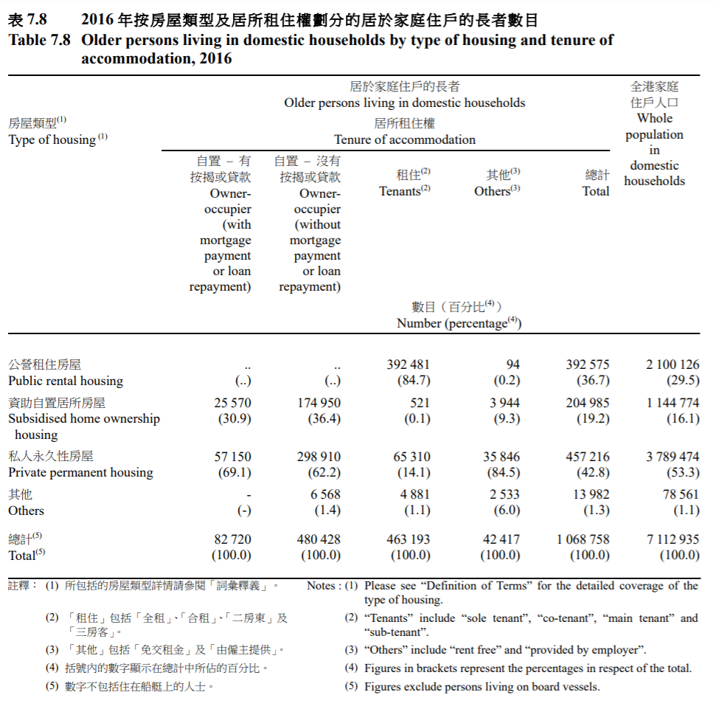
- Type of Special Housing for older people offered by HA
There are two types of special housing offered by the HA:
- Housing for Senior Citizens units which come with communal and recreational facilities under the care of a warden;
- Self-contained Small Flats which are equipped with facilities such as non-slippery floor tiles and single lever taps to cater for the needs of the elderly.
Currently two pilot projects are completed for Housing for Senior Citizens. They are Jolly Place (completed in 2003) and Cheerful Court (completed in 2004). A third pilot is scheduled to be completed in 2022. Below is the layout plan for Jolly Place and Cheerful Court.

Jolly Place
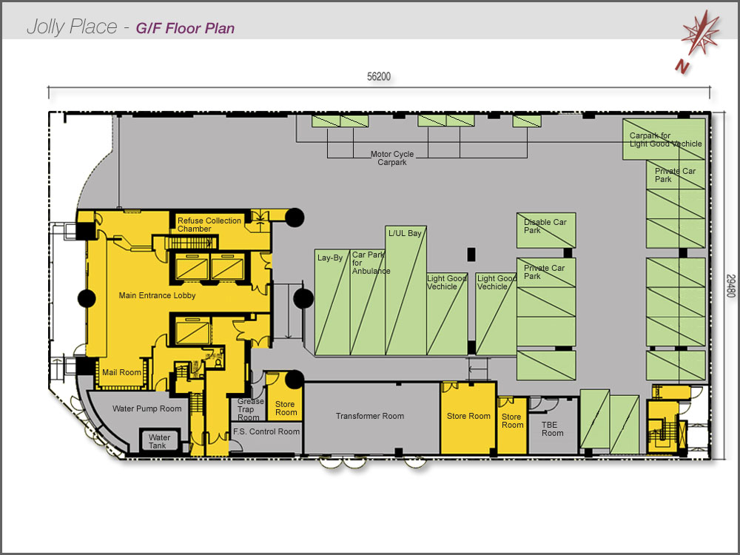
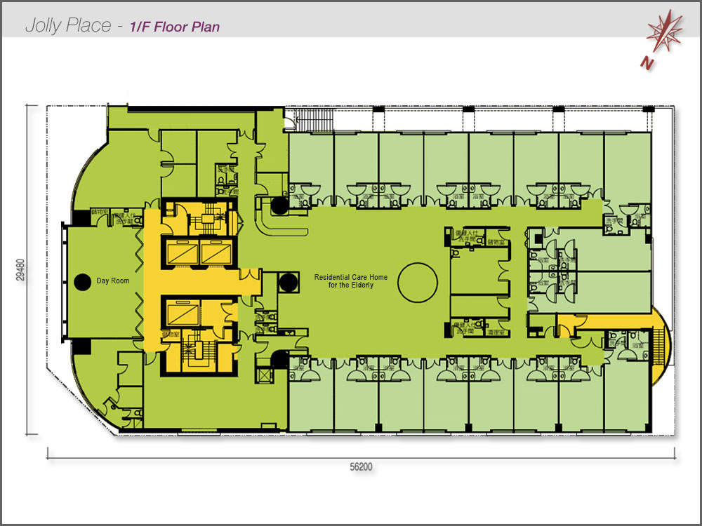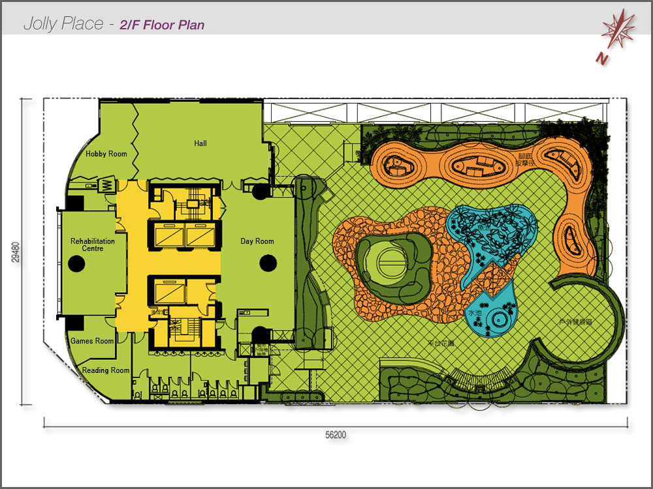
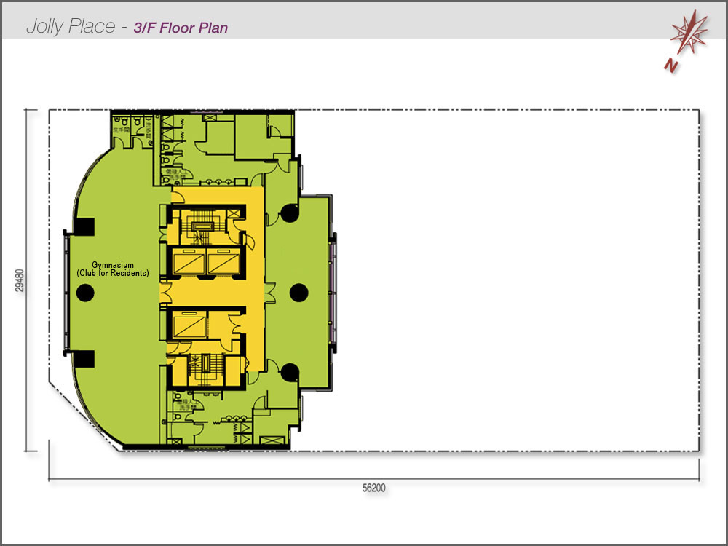
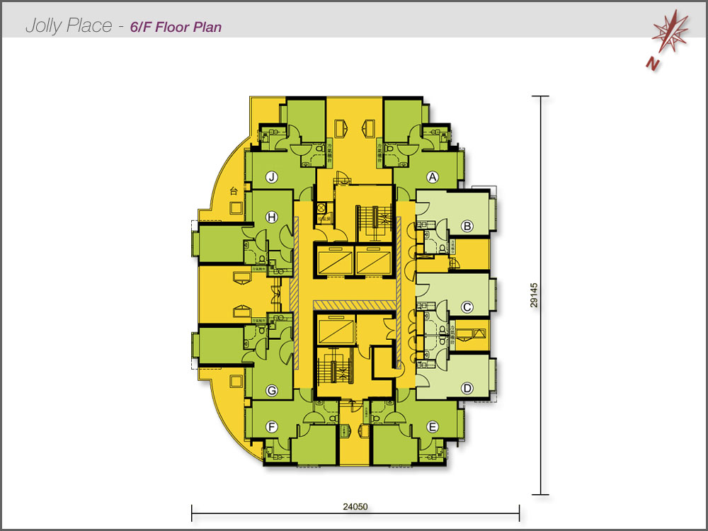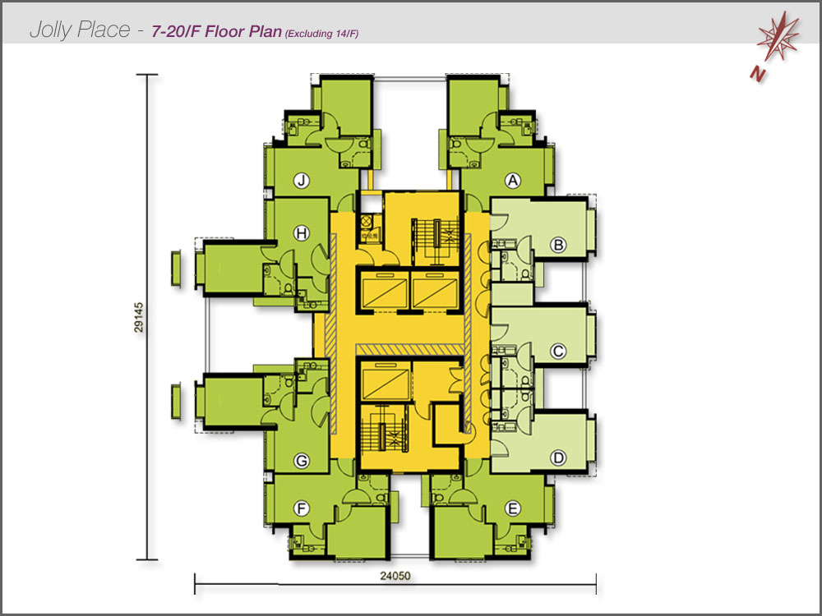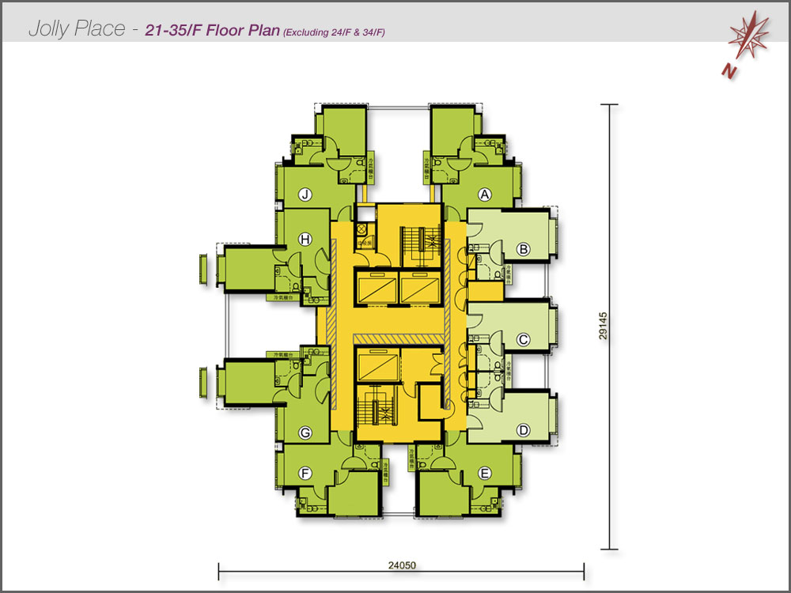

Cheerful Court